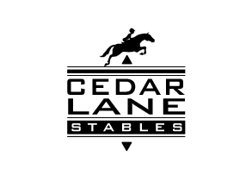
RELEASE OF LIABILITY AND INDEMNIFICATION
(CHILD)

Child/Children: (Print) _______________________________________________________
Child’s Parent/Guardian: (Print) ________________________________________________

Address: _________________________________________________________________
Phone Number: ______________________ Cellular: _______________________________
Emergency Contact (Name/Number): ____________________________________________

Location (the "Premises"): 20520 Cedar Lane, Tomball, Texas 77377, or any other location at which Trainer provides Equine Services as defined below.

This Agreement is between the above Parent/Guardian of Child, and Cedar Lane Stables (the "Trainer"). In consideration of the Trainer providing horse riding lessons, horsemanship training, equitation training, or any other equine related services (the "Equine Services") to the Child, the Trainer and the Parent/Guardian of the Child agree:

- The Trainer hereby grants the Child a license to enter the Premises at the Child's and the Child's Parent/Guardian's own risk and use various areas of the Premises, horses and equipment for the purpose of participating in the Equine Services.
- The Child's Parent/Guardian hereby releases and agrees to defend, protect, indemnify, and save the Trainer, as well as her agents and family members (the "Released and Indemnified Parties"), harmless from and against all liability, claims, costs, expenses including attorney fees, demands, fines, suits, and causes of action of every kind and character (the "Claims"), including but not limited to Claims on account of personal injuries or death or damage to property, arising in favor of any person, corporation or other entity, including the parties hereto, in the presence of Child on the Premises. This indemnity shall apply notwithstanding the fact that any Claim arises in part from the concurrent or contributory negligence of any of the Released and Indemnified Parties. Child's Parent/Guardian undertakes the defense with counsel acceptable to the Released and Indemnified Parties any and all Claims.
- Parent/ Guardian acknowledges that UNDER TEXAS LAW (Chapter 87, Civil Practice and Remedies Code), AN EQUINE PROFESSIONAL IS NOT LIABLE FOR AN INJURY TO OR THE DEATH OF A PARTICIPANT IN EQUINE ACTIVITIES RESULTING FROM THE INHERENT RISKS OF EQUINE ACTIVITIES.

Date Signed: ____________________ ___________________________________
Trainer
_______________________________
Parent/Guardian

